# Lesson 24 单词讲解

1. upset adj. 不安

be upset feel upset

I felt upset last night.

1. complain v. 抱怨

complain about …

He always complains about the weather.

1. contain v. 包含，内装

The envelope contained £50.

include v. 包含

The list included 500 people.

1. honesty n. 诚实honest adj. 诚实的an honest man

[manager](http://dict.cn/manager.htm) ['mænidʒə] n.经理

[wicked](http://dict.cn/wicked.htm) ['wikid] a.很坏的，邪恶的

# Lesson 24 课文&语法讲解

1.I entered the hotel manager’s office and sat down.

2.I had just lost £50 and I felt very upset.

过去完成时 vs. 一般过去时

3.I left the money in my room … leave v. 离开，留下leave left left

1. Everyone’s losing money these days … 现在进行时

am / is / are + doing

1. He started to complain about this wicked world but was interrupted by a knock at the door.（interrupted 第十课）

start to do sth. = start doing sth. complain about …

be interrupted by …

5.‘Well,’ I said to the manager, ‘there is still some honesty in this world !’ There be 句型

基本结构：There be + n. (倒装句)

There is a girl.

含义：“有”（客观存在）

‘Well,’ I said to the manager, ‘there is still some honesty in this world !’

There be 句型

扩展结构：There be + n. + 介词短语

There is a girl in the classroom.

There be + n. + doing There is a girl crying.

‘Well,’ I said to the manager, ‘there is still some honesty in this world !’

There be 句型

扩展结构：There be + n. + 介词短语

There be + n. + doing

There is a girl crying in the classroom.

There were some people rowing on the river.

‘Well,’ I said to the manager, ‘there is still some honesty in this world !’ There be + n.

There is a problem. There was a problem There will be a problem.

There has been a problem.

‘Well,’ I said to the manager, ‘there is still some honesty in this world !’

There be 句型

昨天商店里没有几个人。

There were few people in the shop yesterday.

在我们面前(从过去到现在)一直有很多问题。

There have been many problems in front of us.

# Lesson 24 知识拓展

本课重点:

复习第一单元中讲过的内容

简单句（一件事）的构成

简单句

Girls play games.

Girls are playing games.

Lovely girls are playing games happily.

Thousands of Lovely girls are playing games very happily.

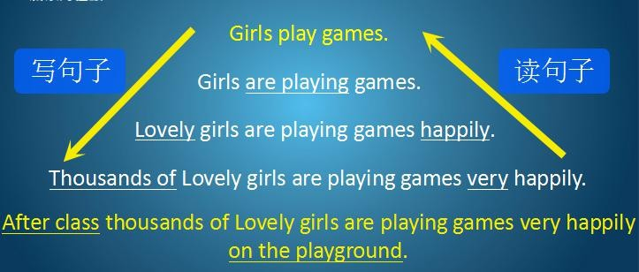After class thousands of Lovely girls are playing games very happily on the playground.

本课重点:

复习第一单元中讲过的内容简单句（一件事）的构成

